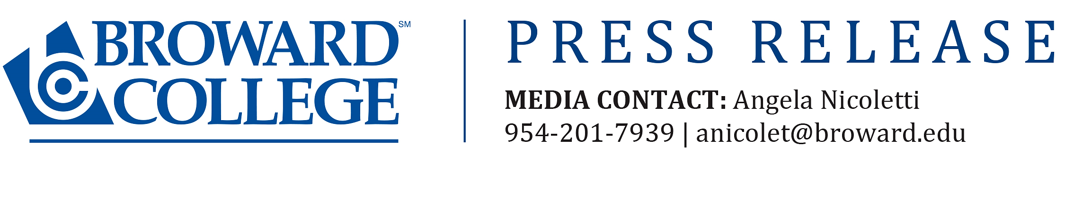

FOR IMMEDIATE RELEASE

Broward College to Host ‘Ignite the Entrepreneurial Spirit’ Event

FORT LAUDERDALE, FL (March 19, 2016) – Broward College will bring together three local business professionals to give their expertise and real-life practical advice on how to use entrepreneurial thinking to succeed in business and life at “Ignite the Entrepreneurial Spirit.” They will also explore how students who pursue their major within the context of a broad liberal arts education substantially increase their likelihood of achieving long-term professional success. This event will take place on Tuesday, March 31, from 11 a.m. to 12:30 p.m. at Judson A. Samuels South Campus, 7200 Pines Blvd., Pembroke Pines, Performing Cultural Arts Theater (PCAT), Building 68b. It is free and open to the public.
“What we wanted was to bring together a diverse selection of speakers that represent and reflect the Broward College student body,” said Walter Burton, Broward College instructor of speech and organizer of the event. “This will be a great opportunity not only for them, but for the community as well to hear someone’s experience in owning and running a business.”
Speakers for the event will include CEO of Premier Legal Advantage Bridget Maguire, who will address the challenges and advantages of being a female CEO, as well as her experiences of working with people from all over the world; Chairman of the Board of O2 Media Mark Alfieri, who will discuss how passion and ambition lead to success; and Rohan Williams, a naturalized immigrant from the Caribbean who has built four successful IT businesses over the last 20 years, who will speak about the challenges and rewards of hard work, focus and drive.
For more information, contact Angela Nicoletti at 954-201-7939 or anicolet@broward.edu.

-BC-

About Broward College:
Serving more than 68,000 students annually, Broward College provides residents with certificate programs, two-year university-transfer degrees, two-year career degrees and baccalaureate degrees in selected programs. The mission of the college is to provide high-quality educational programs and services that are affordable and accessible to a diverse community of learners. For more information, visit www.broward.edu.

